Delray Beach City Population between the 2010 and 2020 Census
in Comparison with Other Florida Cities
Ben Kon – Delray Beach Public Library, 2/19/2022

US Decennial Census Data was obtained for all Census Designated Places (CDPs) in Florida. Of the 955 entries in the 2020 Census, 39 did not have a value with which to compare in 2010 and were thus removed from the analysis, leaving 916 CDPs.
Population of Florida Cities and other CDPs – General Characteristics
The 2020 Census data shows that CDPs in Florida have an average population of 17,945 with a median value of 5,147, indicating many small towns and other sparsely populated areas. There are, of course, several large outliers, including the major metropolitan areas of Jacksonville, Miami, Tampa, Orlando, and St Petersburg in the top five spots. At 66,846, Delray Beach city falls in as the 51st largest place in Florida by population, within the top 6%.
Relative Change in Population for Florida CDPs
The percent change in population was calculated for each place and can be viewed as the relative change in population over the ten-year period. The distribution of this relative change is illustrated by the box plot and kernel density plot below:
Average (mean) relative change: 13.05 %
Standard Deviation: 34.83 %
Median relative change: 7.78%
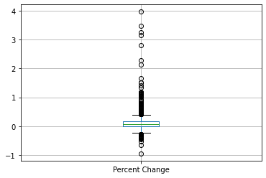
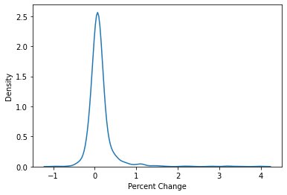
Delray Beach shows a percent change in population of 10.45%, above the median value, but below the mean. Its relative change in population is greater than about 60% of all other CDPs in Florida over the ten-year period. Nearby cities with similar relative changes in population between 2010 and 2020 include Ft. Lauderdale (10.41%), Jupiter (10.68%), and Lantana (10.37%).
Given the number of outliers at the higher end of this dataset, and seeing that many of these are smaller communities, where moderate changes in actual population may translate to a much more significant value for relative change, it may also be beneficial to look at the raw numerical differences, or absolute change, in population.
Geographic Area Name | 2020 Census | 2010 Census | Percent Change | Population Difference
Nocatee CDP, Florida | 22503 | 4524 | 397.41% | 17979
Balm CDP, Florida | 6541 | 1457 | 348.94% | 5084
Fisher Island CDP, Florida | 561 | 132 | 325.00% | 429
Horizon West CDP, Florida | 58101 | 14000 | 315.01% | 44101
Silver Springs Shores CDP, Florida | 24846 | 6539 | 279.97% | 18307
Freeport city, Florida | 5861 | 1787 | 227.98% | 4074
Davenport city, Florida | 9043 | 2888 | 213.12% | 6155
Wabasso CDP, Florida | 1627 | 609 | 167.16% | 1018
Viera West CDP, Florida | 16688 | 6641 | 151.29% | 10047
Connerton CDP, Florida | 5282 | 2116 | 149.62% | 3166
Sample Table 1 – Ten Florida places with greatest percent change in population

Absolute Population Change of Florida CDPs
Distributions for the absolute change in population for all Florida CDPs are shown below. The population of Delray Beach increased by 6,324 persons between the 2010 and 2020 Census. This is a greater absolute increase in population than 90% of all other CDPs in Florida, well above both the median and mean values. Nearby places with similar increases in population include Lake Worth (7,309 persons), Greenacres (6,417 persons), and Jupiter (5,891 persons).
Average (mean) absolute change: 2,362 persons
Standard Deviation: 7,094 persons
Median absolute change: 293 persons

As with the values for percent change, the data is concentrated with strong central tendencies but with a significant number of large outliers. However, in contrast with the values for relative change, here those high values correlate more closely to those CDPs with large populations.

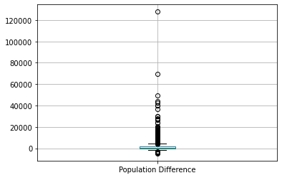
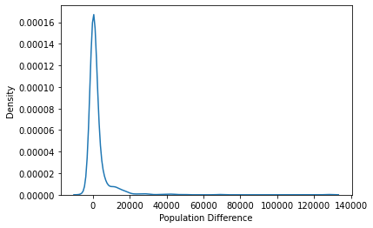

Geographic Area Name | 2020 Census | 2010 Census | Percent Change | Population Difference
Jacksonville city, Florida | 949611 | 821784 | 15.55% | 127827
Orlando city, Florida | 307573 | 238300 | 29.07% | 69273
Tampa city, Florida | 384959 | 335709 | 14.67% | 49250
Horizon West CDP, Florida | 58101 | 14000 | 315.01% | 44101
Miami city, Florida | 442241 | 399457 | 10.71% | 42784
Port St. Lucie city, Florida | 204851 | 164603 | 24.45% | 40248
Cape Coral city, Florida | 194016 | 154305 | 25.74% | 39711
Riverview CDP, Florida | 107396 | 71050 | 51.16% | 36346
Four Corners CDP, Florida | 56381 | 26116 | 115.89% | 30265
Doral city, Florida | 75874 | 45704 | 66.01% | 30170
Sample Table 2 – Ten Florida places with greatest raw increase in population from 2010-2020

Palm Beach County CDPs
Palm Beach County has a total of 39 Census Designated Places, all of which were incorporated prior to 2010 except for the city of Westlake. Comparing both the percent change in population as well as the raw difference between 2020 and 2010, one may note a similar standing for Delray Beach as when compared to CDPs throughout the state.
Average (mean) percent change: 10.65 %
Standard Deviation: 10.33 %
Median percent change: 10.5%

In terms of percent change, Delray Beach (10.45%) falls right around the median and mean values for Palm Beach County. Here, the only notable outlier in this smaller data set is Palm Springs, with a population increase of 42% over the ten-year period.

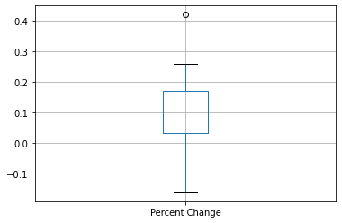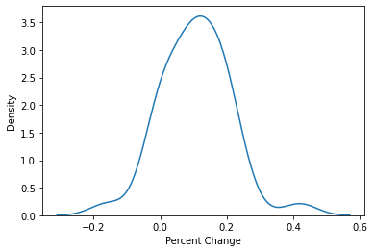

Again, in terms of raw population increase, Delray Beach’s contribution (6,324 persons) seems more significant, making it the 9th largest increase in Palm Beach County, greater than 76% of the other CDPs in this area. The full Palm Beach County list is provided in Table 3, below.
Average (mean) population change: 2,362 persons
Standard Deviation: 7,094 persons
Median population change: 293 persons
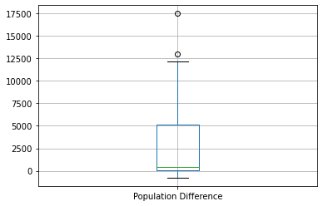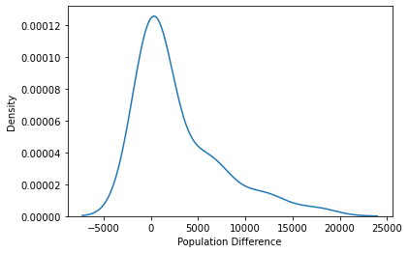

Geographic Area Name | 2020 Census | 2010 Census | Percent Change | Population Difference
West Palm Beach city, Florida | 117415 | 99919 | 17.51% | 17496
Boca Raton city, Florida | 97422 | 84392 | 15.44% | 13030
Boynton Beach city, Florida | 80380 | 68217 | 17.83% | 12163
Palm Beach Gardens city, Florida | 59182 | 48452 | 22.15% | 10730
Palm Springs village, Florida | 26890 | 18928 | 42.06% | 7962
Lake Worth Beach city, Florida | 42219 | 34910 | 20.94% | 7309
Greenacres city, Florida | 43990 | 37573 | 17.08% | 6417
Delray Beach city, Florida | 66846 | 60522 | 10.45% | 6324
Jupiter town, Florida | 61047 | 55156 | 10.68% | 5891
Wellington village, Florida | 61637 | 56508 | 9.08% | 5129
Riviera Beach city, Florida | 37604 | 32488 | 15.75% | 5116
Royal Palm Beach village, Florida | 38932 | 34140 | 14.04% | 4792
North Palm Beach village, Florida | 13162 | 12015 | 9.55% | 1147
Lantana town, Florida | 11504 | 10423 | 10.37% | 1081
Palm Beach town, Florida | 9245 | 8348 | 10.75% | 897
Lake Park town, Florida | 9047 | 8155 | 10.94% | 892
Highland Beach town, Florida | 4295 | 3539 | 21.36% | 756
Juno Beach town, Florida | 3858 | 3176 | 21.47% | 682
Tequesta village, Florida | 6158 | 5629 | 9.40% | 529
Haverhill town, Florida | 2187 | 1873 | 16.76% | 314
South Palm Beach town, Florida | 1471 | 1171 | 25.62% | 300
Mangonia Park town, Florida | 2142 | 1888 | 13.45% | 254
Palm Beach Shores town, Florida | 1330 | 1142 | 16.46% | 188
Lake Clarke Shores town, Florida | 3564 | 3376 | 5.57% | 188
Loxahatchee Groves town, Florida | 3355 | 3180 | 5.50% | 175
Gulf Stream town, Florida | 954 | 786 | 21.37% | 168
Atlantis city, Florida | 2142 | 2005 | 6.83% | 137
Hypoluxo town, Florida | 2687 | 2588 | 3.83% | 99
Ocean Ridge town, Florida | 1830 | 1786 | 2.46% | 44
Manalapan town, Florida | 419 | 406 | 3.20% | 13
Jupiter Inlet Colony town, Florida | 405 | 400 | 1.25% | 5
Golf village, Florida | 255 | 252 | 1.19% | 3
Cloud Lake town, Florida | 134 | 135 | -0.74% | -1
Glen Ridge town, Florida | 217 | 219 | -0.91% | -2
South Bay city, Florida | 4860 | 4876 | -0.33% | -16
Briny Breezes town, Florida | 502 | 601 | -16.47% | -99
Pahokee city, Florida | 5524 | 5649 | -2.21% | -125
Belle Glade city, Florida | 16698 | 17467 | -4.40% | -769
Table 3 – Palm Beach County CDPs, ordered by absolute change from 2010-2020
Conclusions
Values for relative change in population (those that express percent change relative to the initial population) will tend to favor areas with small populations, while those with large populations that show consistent rates of growth will often stand out more in terms of absolute change, the raw difference in numbers. Delray Beach shows respectable growth using either metric but is somewhat more impressive in terms of absolute change in population. This statement holds both when compared with other Census Designated Places in Palm Beach County as well as when compared with populations throughout Florida.

References
U.S. Census Bureau. 2010: DEC Redistricting Data (PL 94-171), Table P1, All Places in Florida. Retrieved from data.census.gov on February 2, 2022.
U.S. Census Bureau. 2020: DEC Redistricting Data (PL 94-171), Table P1, All Places in Florida. Retrieved from data.census.gov on February 2, 2022.

